**SCREENSHOT FILE**

**COURSE END PROJECT 2: REAL-TIME DATA MANAGEMENT**

**Steps for implementation:**

**Step 1: Create a Producer Lambda function**

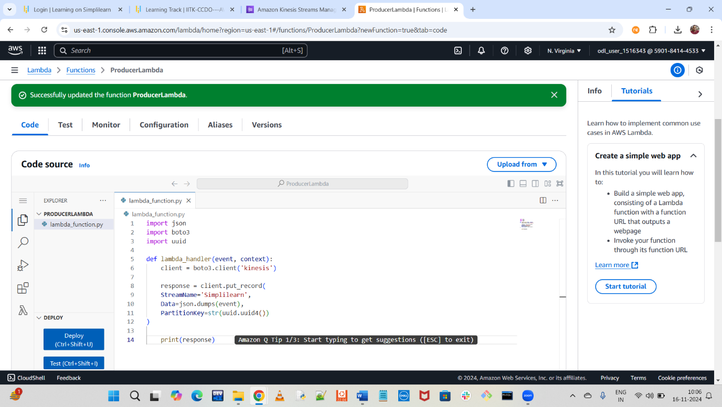

**Step 2: Create Kinesis Data Stream**

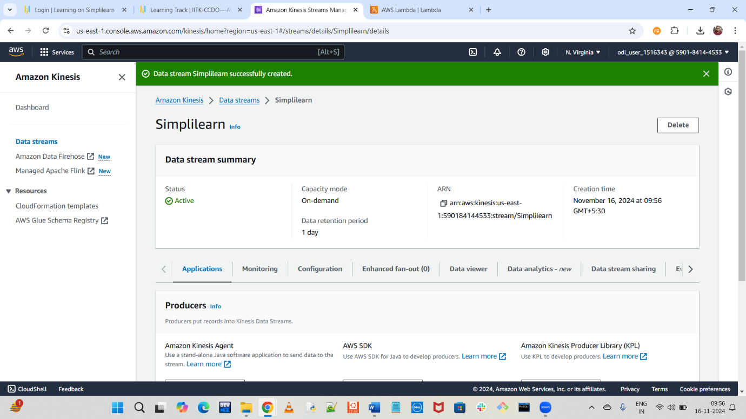

**Step 3: Create a Consumer Lambda function**

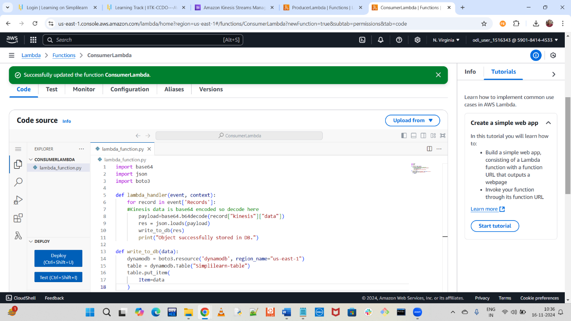

**Step 4: Create Dynamodb Database**

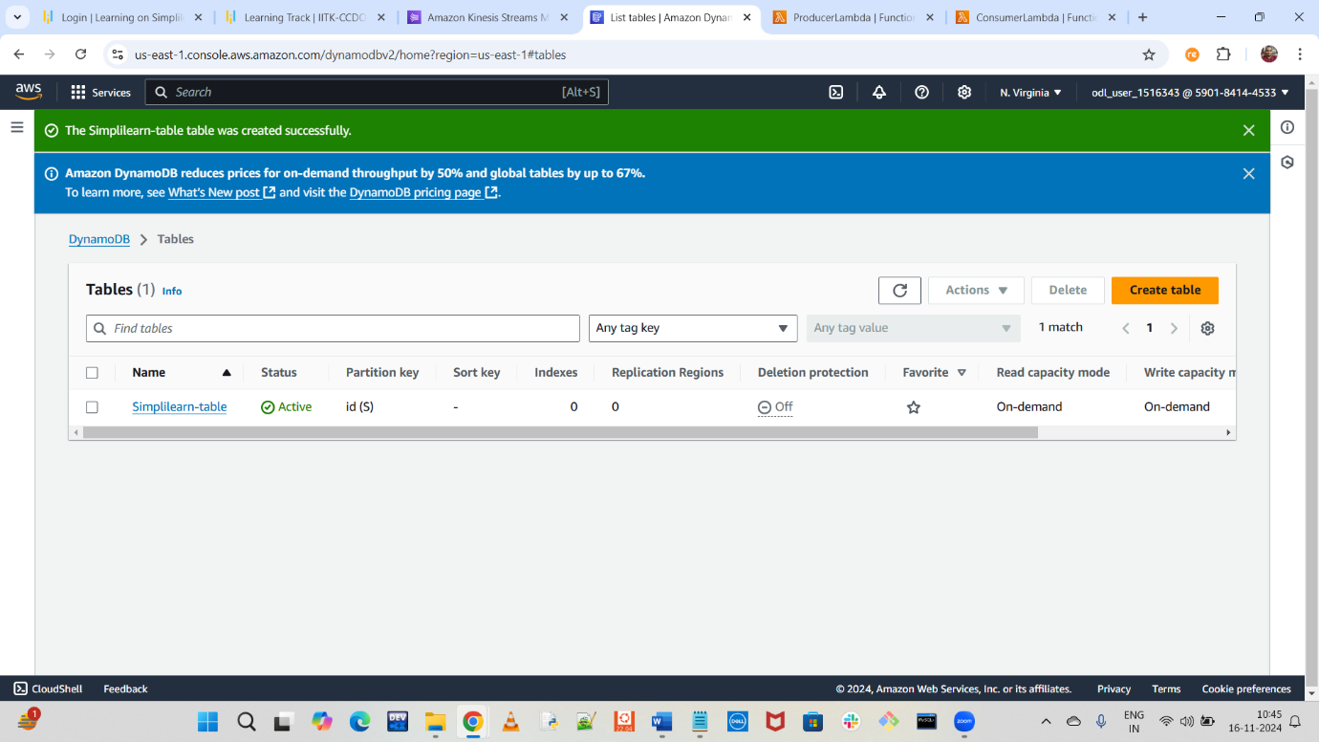

**Steps 5: Perform tests**

